Assignment EMI

**Data Acquisition:**

* **Data acquisition** is the process of sampling signals that measure real-world physical conditions and converting the resulting samples into digital numeric values that can be manipulated by a computer.
* The systems, used for data acquisition are known as **data acquisition systems**. These data acquisition systems will perform the tasks such as conversion of data, storage of data, transmission of data and processing of data.

Data acquisition systems consider the following **analog signals**.

* Analog signals, which are obtained from the direct measurement of electrical quantities such as DC & AC voltages, DC & AC currents, resistance and etc.
* Analog signals, which are obtained from transducers such as LVDT.

**Types of Data Acquisition Systems on the basis of system used:**

Data acquisition systems can be classified into the following **two types**.

* Analog Data Acquisition Systems
* Digital Data Acquisition Systems

### Analog Data Acquisition Systems

The data acquisition systems, which can be operated with analog signals are known as **analog data acquisition systems**. Following are the blocks of analog data acquisition systems.

* **Transducer** − It converts physical quantities into electrical signals.
* **Signal conditioner** − It performs the functions like amplification and selection of desired portion of the signal.
* **Display device** − It displays the input signals for monitoring purpose.
* **Graphic recording instruments** − These can be used to make the record of input data permanently.
* **Magnetic tape instrumentation** − It is used for acquiring, storing & reproducing of input data.

### Digital Data Acquisition Systems

The data acquisition systems, which can be operated with digital signals are known as **digital data acquisition systems**. So, they use digital components for storing or displaying the information.

Mainly, the following **operations** take place in digital data acquisition.

* Conversion of analog signals into digital signals or digital data
* Processing of digital signals or digital data

Following are the blocks of **Digital data acquisition systems**.

* **Transducer** − It converts physical quantities into electrical signals.
* **Signal conditioner** − It performs the functions like amplification and selection of desired portion of the signal.
* **Multiplexer** − connects one of the multiple inputs to output. So, it acts as parallel to serial converter.
* **Analog to Digital Converter** − It converts the analog input into its equivalent digital output.
* **Display device** − It displays the data in digital format.
* **Digital Recorder** − It is used to record the data in digital format.

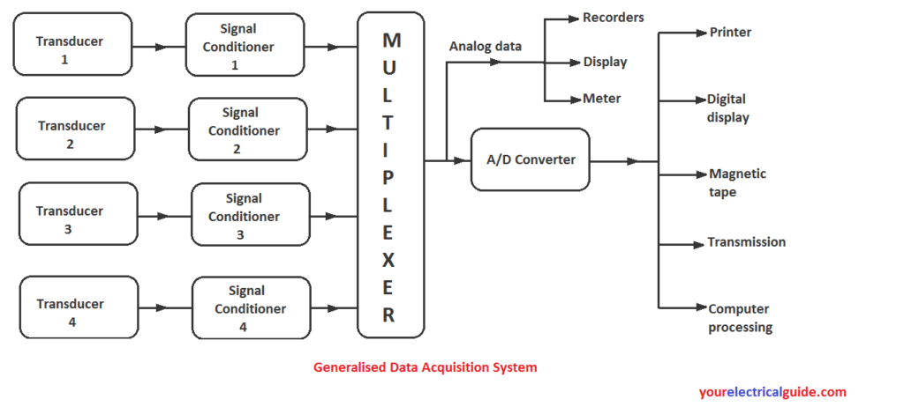

# Analogue to Digital Converter

* An A/D converter is a device that converts analog signals (usually voltage) obtained from environmental (physical) phenomena into digital format.
* The process of taking an analogue voltage signal and converting it into an equivalent digital signal can be done in many different ways.
* One simple and easy way is by using parallel encoding, also known as flash, or multiple comparator converters.
* It consist of interconnected but equally spaced comparators.

Comparator Circuit:

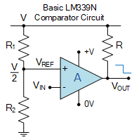

### 2-bit Analogue to Digital Converter Circuit

In general, 2n– 1 comparators would be required for conversion of an “n”-bit binary output, where “n” is typically in the range from 8 to 16. Thus to create 2-bits ADC we need 22– 1 which is “3” comparators.

Here in this simple 2-bit ADC example we have assumed for simplicity that the input voltage VIN is between 0 and 4 volts, so have set VREF and the resistive voltage-divider network to drop 1 volt across each resistor.

When VIN is between 0 and 1 volt, (<1V) the input on all three comparators will be less than the reference voltage, so their outputs will be LOW and the encoder will output a binary zero (00) condition on pins Q0 and Q1. When VIN increases and exceeds 1 volt but is less than 2 volts, (1V<VIN<2V) comparator U1 which has a reference voltage input set at 1 volt, will detect this voltage difference and produce a HIGH output. The priority encoder which is used as the 4-to-2 bit encoding detects the change of input at D1 and produces a binary output of “1” (01).

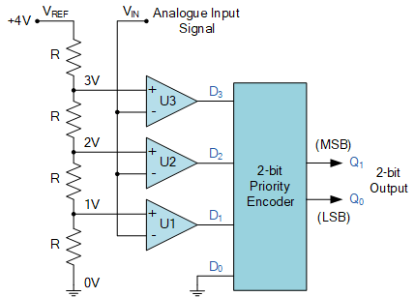

|  |  |  |  |  |  |  |
| --- | --- | --- | --- | --- | --- | --- |
| Analogue Input Voltage (VIN) | Comparator Outputs | | | | Digital Outputs | |
| D3 | D2 | D1 | D0 | Q1 | Q0 |
| 0 to 1 V | 0 | 0 | 0 | **0** | 0 | 0 |
| 1 to 2 V | 0 | 0 | **1** | X | 0 | 1 |
| 2 to 3 V | 0 | **1** | X | X | 1 | 0 |
| 3 to 4 V | **1** | X | X | X | 1 | 1 |

Where: “X” is a “don’t care”, that is either a logic “0” or a logic “1” condition.

### 3-bit Analogue to Digital Converter Circuit

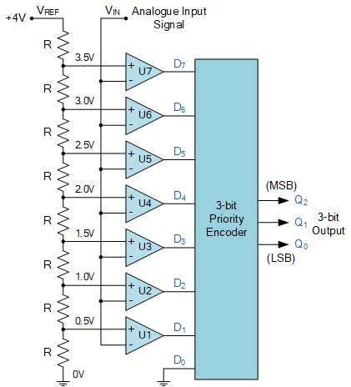

|  |  |  |  |  |  |  |  |  |  |  |  |
| --- | --- | --- | --- | --- | --- | --- | --- | --- | --- | --- | --- |
| Analogue Input Voltage (VIN) | Comparator Outputs | | | | | | | | Digital Outputs | | |
| D7 | D6 | D5 | D4 | D3 | D2 | D1 | D0 | Q2 | Q1 | Q0 |
| 0 to 0.5 V | 0 | 0 | 0 | 0 | 0 | 0 | 0 | **0** | 0 | 0 | 0 |
| 0.5 to 1.0 V | 0 | 0 | 0 | 0 | 0 | 0 | **1** | X | 0 | 0 | 1 |
| 1.0 to 1.5 V | 0 | 0 | 0 | 0 | 0 | **1** | X | X | 0 | 1 | 0 |
| 1.5 to 2.0 V | 0 | 0 | 0 | 0 | **1** | X | X | X | 0 | 1 | 1 |
| 2.0 to 2.5 V | 0 | 0 | 0 | **1** | X | X | X | X | 1 | 0 | 0 |
| 2.5 to 3.0 V | 0 | 0 | **1** | X | X | X | X | X | 1 | 0 | 1 |
| 3.0 to 3.5 V | 0 | **1** | X | X | X | X | X | X | 1 | 1 | 0 |
| 3.5 to 4.0 V | **1** | X | X | X | X | X | X | X | 1 | 1 | 1 |

Data Acquisition System on the basis of technique used

There are two types:

# 1- Single Channel Data Acquisition System

* The channel in a data acquisition system fundamentally represents an input source which we wish to measure, digitize and do further processing.
* In single channel DAS there is only one channel present( ie., only one input source).

**Components of Single Channel DAS:**

**Transducers:** If the input is non electrical signal then it is converted into electrical signal with the help of transducers and if it electrical signal then sensors are used in place of transducers.

**Signal Conditioning:**  If the modification, amplification or filteration is required then it is done with the help of this Signal Conditioning Block.

**ADC( Analog to Digital Converter):** The analog signal is converted into Digital signal with the help of this ADC. As the transmition of digital signal is done easily as compared to analog and many operation can be performed on digital data as compared to analog signals.

* Some time Buffer is connected after ACD.

The rate of conversion is internally determined. The digital outputs from the buffer are fed to a storage system or a printer or to a computer for further analysis.

|  |
| --- |
| Single channel acquisition system |
|  |

A known example of the single channel DAS is the digital panel meter [DPM].

## **2 - Multi Channel Data Acquisition System:**

## **In multichannel DAS there is multi-channel present (ie., there are multiple input sources). The block diagram of the Multichannel DAS is shown in figure:**

## 

## **Multiplexer gives one output by combining multiple inputs which is fed to **Sample and Hold Circuit(S/H)** which is given to ADC to give digital output. The rest of procedure is same as Single Channel DAS.**

## **Data Logger:**

## **Data logger are the devices used to measure and store the reading of the instruments without any loss of accuracy. They are the application of data acquisition system. The output of the transducer can be measured and the value is logged automatically by the data logger.**

## ****Block diagram of data Logger****

## What is Data logger? Block Diagram, Parts, & Functions - ElectricalWorkbook

## **1 – Input Scanner:**

## **The various input signals fed to the input scanner are temperature, pressure, vibrations, ON/OFF signals etc. The input Scanner is an automatic switch that can select only one input signal at a time.**

## **2 – Signal Amplifier and Conditioner**

## **The input signal selected by the scanner is a low level signals. Hence a signal amplifier is used to amplify the low level signal so that the input signal is maintained at 5V level.**

## **The signal is placed between scanner and analog to digital converter. It is a linearising circuit i.e., If a signal varies non linearly with respect to the measured parameter then linearization of the signal is done by signal conditioner.**

## **3 – Analog to Digital Converter**

## **The data logger handle the data only in digital form and hence the analog signal, if any , have to converted into digital form by analog to digital converter.**

## **4 – Recorder**

## **The data logger drives the output recorder which prints the signals obtained from the analog to digital converters. The recorder may consists of either typewriter or a punched tape.**

## **5 – Programmer**

## **It control the sequence of operation of all the other units of data logger. It performs various functions like starting analog to digital conversion, selecting inputs signal by scanner, recording and displaying reading, resetting logger etc.**

## **6 – Clock**

## **The clock is used to automate the entire data logging system. When the clock signal is generated the scanning operation is started then data logger advances ahead by time. The clock gives command to the programmer to start logging sequence at the interval selected by the user.**

## 

## ****Liquid Vapour Display (LVD):****

## It is uses a reflective passive display principle and depend on the presence of ambient lights for their operation.

## 

## It consists of a transparent volatile liquid encased between two glass plates and side spacers. The rear glass plate has a black background and the front glass surface in contact with the liquid is roughed, so that the liquid wets it.

## The [transparent electrode](http://www.eeeonline.org) is heated by using a voltage drive, which is the basis for the display function.

## In the OFF condition of display with no voltage applied across the transparent [electrode](https://www.eeeguide.com/frequency-calibration/), the viewer sees the black background through the front transparent glass electrode and the liquid.

To achieve an ON condition of the display, a voltage is applied to the transparent electrode. This causes sufficient heat in the electrode, which evaporates the liquid in contact with it, and a combination of vapour film and vapour bub­bles is formed around the roughened [glass surface](https://www.eeeguide.com/diffusion/). As the refractive index of vapour is approximately 1, there is a discontinuity established at the interface between the front glass plate and the liquid, which gives rise to light scattering. This makes it a simple display device.

The organic liquid selected for Liquid Vapour Display should have the following features.

1. Refractive index close to that of the glass plate.
2. Minimum energy for vaporising the liquid in contact with the roughened

# **Liquid Crystal Display(LCD)**

* Liquid Crystal Display (LCD) is an flat  display screen used in electronic devices such as laptop, computer, TV, cellphones and portable video games. As the name says liquid crystal is a material which flows like a liquid and shows some properties of solid.
* As the name says the molecular structure of liquid crystal is in between solid crystal and liquid isotropic.
* Here we use Twisted Nematic Liquid Crystal (It twist light by 90 degree). If we apply any voltage across it its twisting ability get lost.

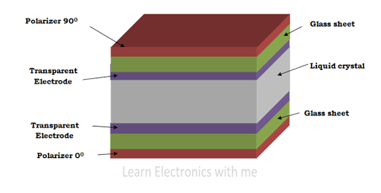

Construction of LCD

* Construction of LCD consists of two polarized glass pieces (Horizontal and Vertical) . Two electrodes are used, one is positive and the other one is negative. External potential is applied to LCD through this electrodes and it is made up of indium-tin-oxide. Liquid crystal layer of about 10µm- 20µm is placed between two glass sheets. The light is passed or blocked by changing the polarization.

## **\*\*\*\*\*\*\*\*\*\*\*\* ***Working Procedure in rough copy*** \*\*\*\*\*\*\*\*\*\***

### Advantages:

* It is thin and compact
* Low power consumption
* Less heat is emitted during operation
* Low cost

### Disadvantages:

* Speed of operation is low
* Lifespan is less
* Restricted viewing angles

### Applications:

* Used in digital wrist watch
* Display images in digital cameras
* Used in numerical counters
* Display screen in calculators
* Mainly used in television
* Used in mobile screens
* Used in video players
* Used in image sensing circuits